

KULIYYAH OF INFORMATION AND COMMUNICATION TECHNOLOGY

**SEMESTER 1 2018/2019**

**INFO 2302**

**WEB TECHNOLOGIES**

**SECTION 1**

**WEBSITE:**

EDIBLE

**GROUP NAME:**

ALPHA

**NAME AND MATRIC NO:**

NADIA NATASHA BINTI ABD AZIZ 1719870

NUR IZYAN BINTI ROSLI 1718844

MUHAMMAD KAMIEL BIN SAMSUDIN 1713493

**LECTURER’S NAME:**

MADAM MARINI BINTI OTHMAN

|  |
| --- |
| **TABLE OF CONTENT** |

|  |  |  |
| --- | --- | --- |
| **NO.** | **TITLE** | **PAGE NO.** |
|  | Introduction | 3 |
|  | Implementation | 4 |
|  | Sitemap | 5 |
|  | Screenshots of Website | 6-8 |
|  | Tasks Distribution | 9 |
|  | References | 10 |

|  |
| --- |
| **1.0 INTRODUCTION** |

Edible is a website that we created to introduce the varieties of Malaysian Cuisine to our target audience, which are both Malaysian and non-Malaysian. This website helps people to differentiate Malaysian food that are categorised based on the races that we have in Malaysia, which are Malay, Chinese and Indian. At the same time, we are actually promoting Malaysian Food to the tourists.

For this website, we have five main navigations which are ‘Home’, ‘Categories’, which consists of Malay, Chinese and Indian, ‘Popular’, ‘About’ and ‘Contact’. We use blue and white colours as our main theme for this website to maintain the minimal design to make it easy on the eyes.

In every page, we have banner on the top with the same design. For the ‘Home’ page, we have slideshow and three photos that link to each category. Next, for each category, we have main dish and side dish tabs that display the food of that particular race together with the description. For example, for ‘Malay’ food page, we have Nasi Lemak and Asam Pedas for the main dish while for the side dish, we have Currypuff and Keropok Lekor. We also include a ‘View More’ button for every food that will display a pop-up. The pop-up contains a suggested restaurant of that particular food, ratings, and a map that directs to ‘Google Map’ when user clicks it.

We also have ‘Popular’ page that shows restaurants that get most visits from people and they gave their reviews to share their thoughts and experiences. We also include a direction button that directs to ‘Google Map’. ‘About’ contains the description of our webpage, while ‘Contact’ contains our contact information to assist people to reach us.

|  |
| --- |
| **2.0 IMPLEMENTATION** |

In our coding, we use HTML, CSS and JavaScript to develop our website. HTML is the standard mark-up language for creating web pages and web applications while CSS is for styling. JavaScript is a scripting or programming language that allows us to implement complex things on web pages. We developed our website from scratch without using templates such as Bootstrap or JQueryUI from third party resources. However, we did utilise a third party-resource in our functionality of the website, which is the Google Maps API that we use in our popups. In our website, we use JavaScript to display the slideshow in the ‘Home’ page and to make the header hidden when user scrolls down the page.

Next, we also implement JavaScript in the ‘Categories’ page to allow user to switch from main dish tab to side dish tab with different contents. JavaScript also has been applied to display the popups for every food. The last JavaScript that we used is to allow user to click the ‘like’ or ‘dislike’ button in the ‘Popular’ page.

|  |
| --- |
| **3.0 SITEMAP** |

Chart above shows the sitemap of Edible website.

|  |
| --- |
| **4.0 SCREENSHOTS OF WEBSITE** |

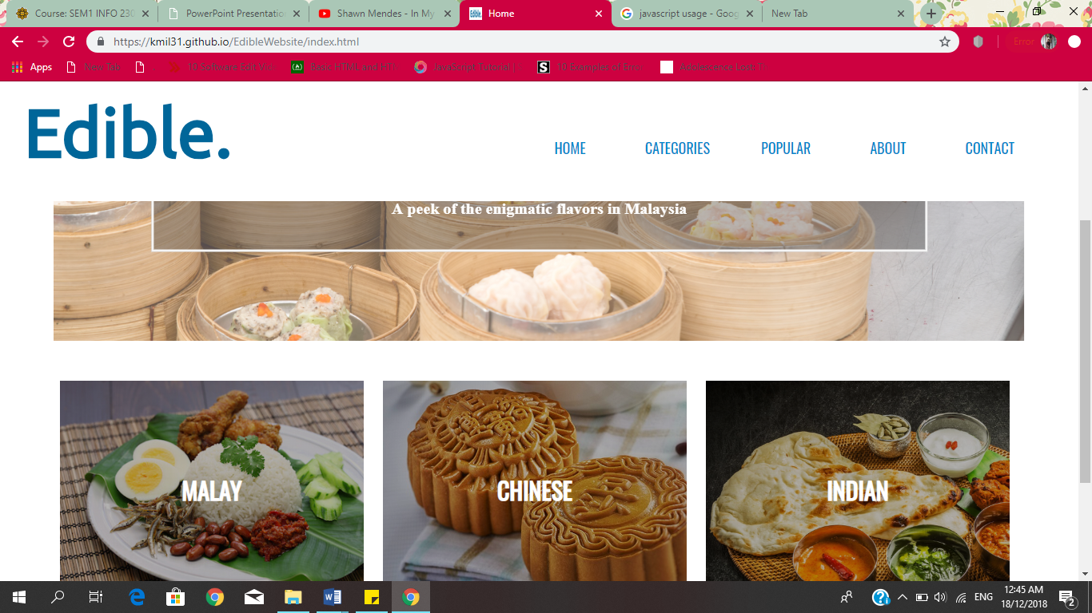

Figure 1: Home page of Edible website

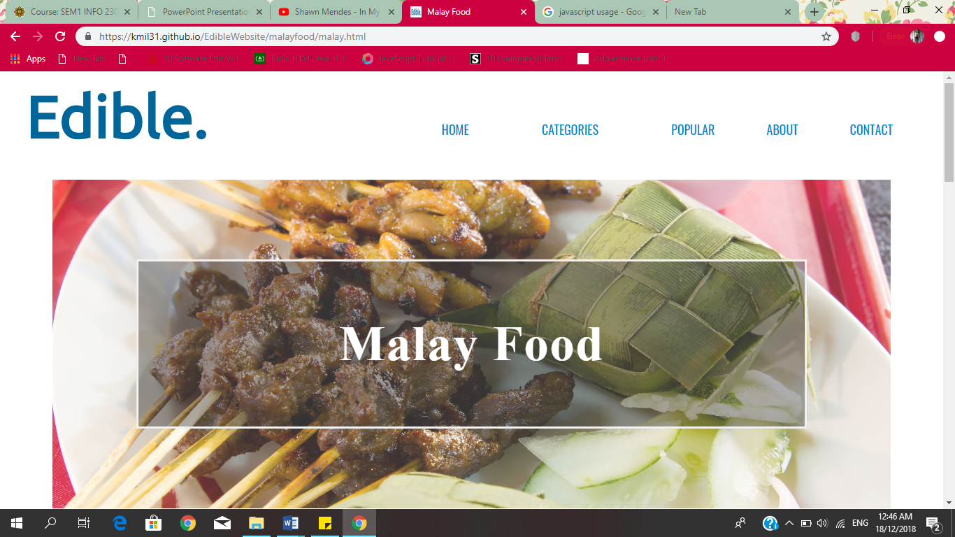

Figure 2: Malay food page of Edible website

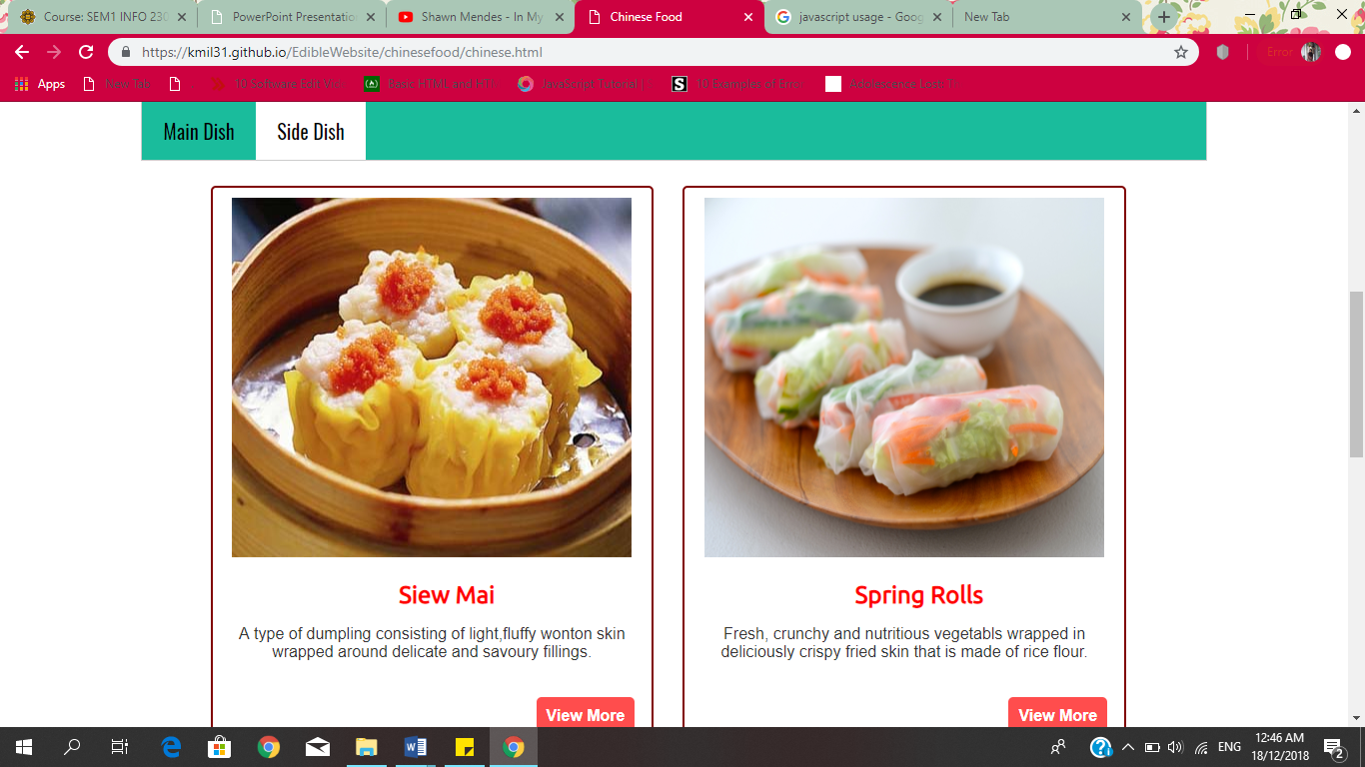

Figure 3: Side dish tab of Chinese food page

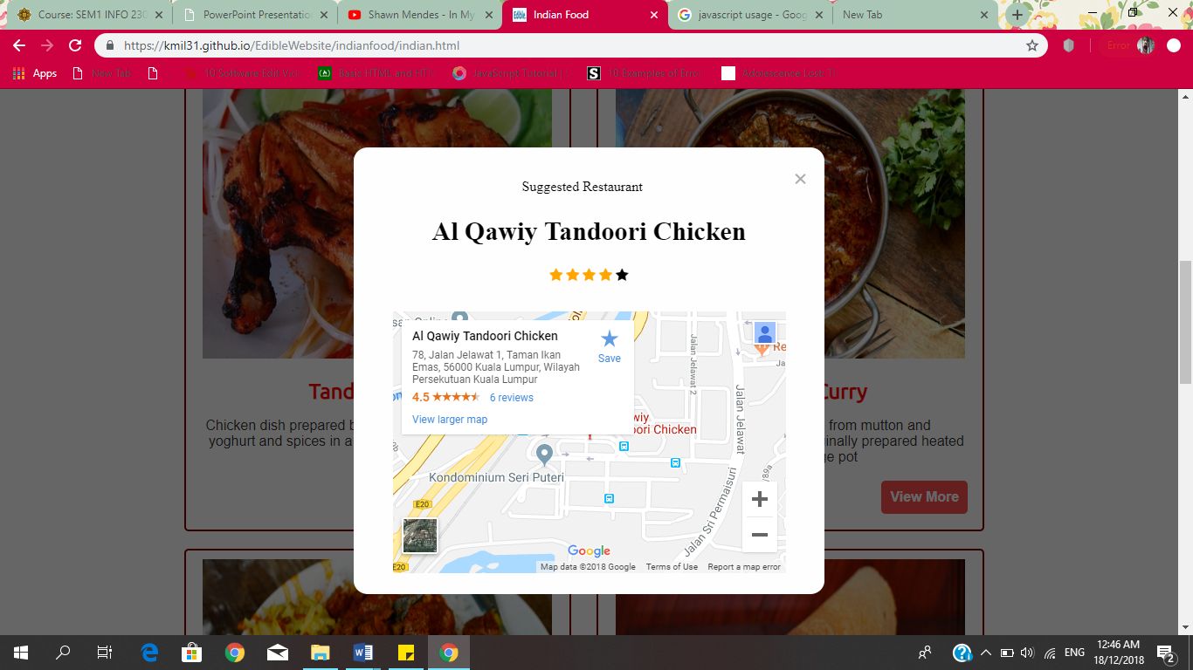

Figure 4: Pop-up box of ‘View More’ button

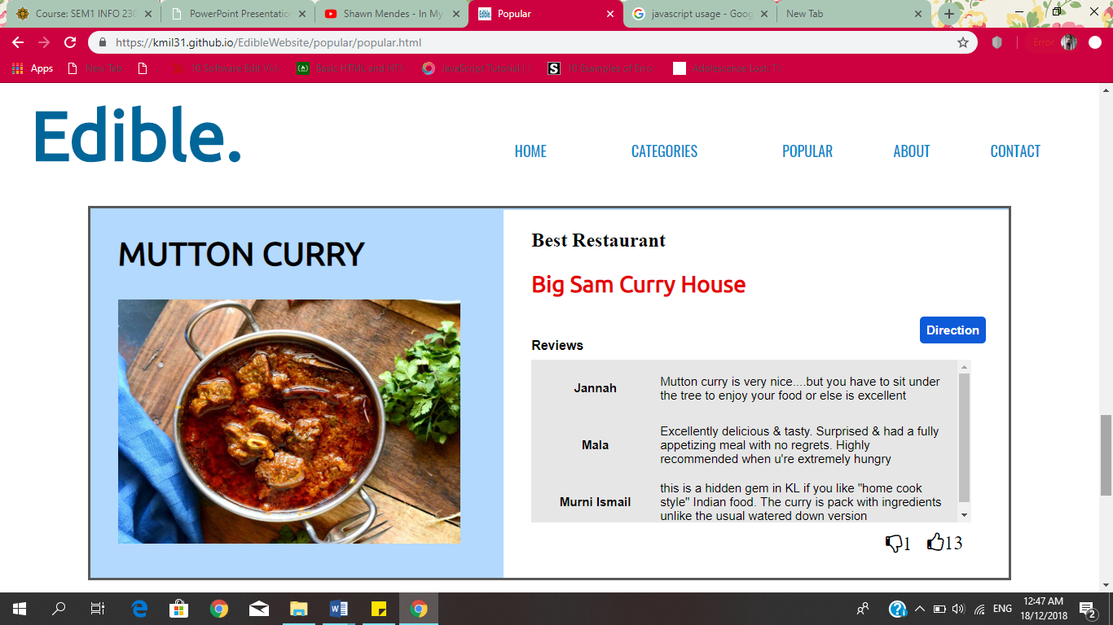

Figure 5: Popular page of Edible website

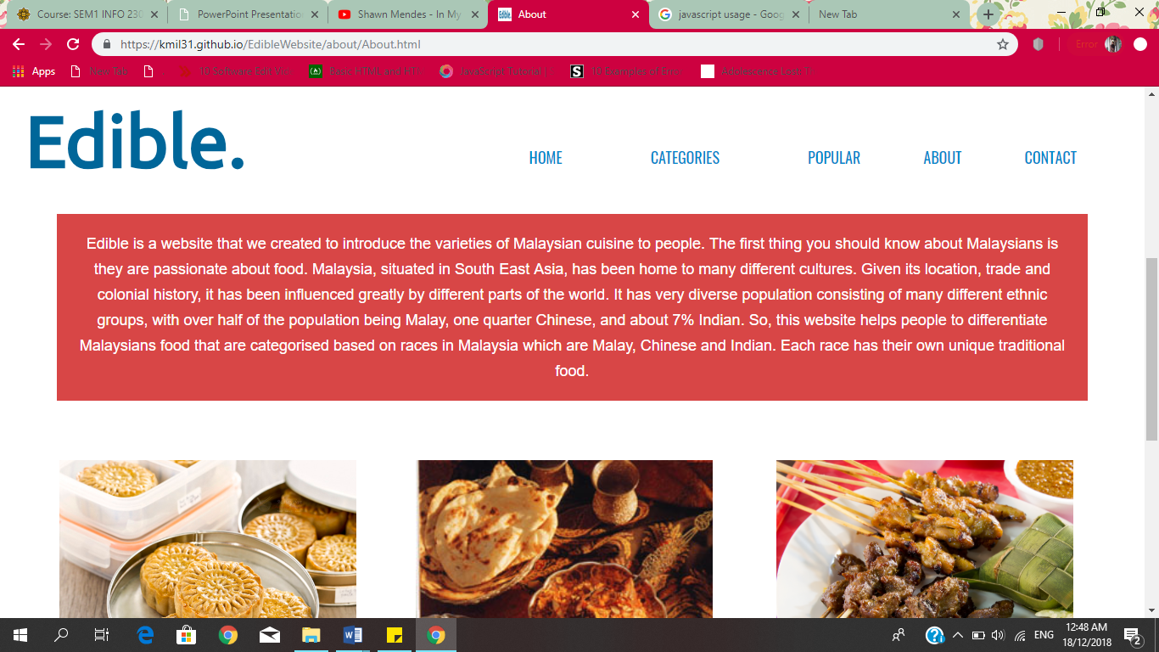

Figure 6: About page of Edible website

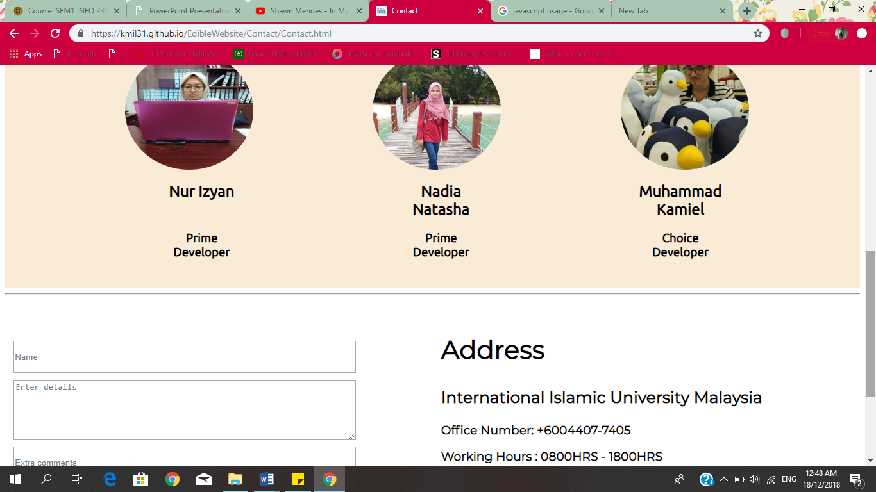

Figure 7: Contact page of Edible website

|  |
| --- |
| **5.0 TASK DISTRIBUTION** |

|  |  |
| --- | --- |
| **Name** | **Contributions** |
| Nur Izyan | * Home page * Indian food page * Main dish * Side dish * Popular page |
| Nadia Natasha | * About page * Malay food page * Main dish * Side dish * JavaScript of pop-up box |
| Muhammad Kamiel | * Contact page * Chinese food page * Main dish * Side dish * Slideshows of Home page |

|  |
| --- |
| **6.0 REFERENCES** |

1. HTML. (n.d.). Retrieved on 23rd October 2018 from <https://www.w3schools.com/>
2. RandellDawson. (2018, July 19). Easy and more efficient way to show multiple Popup modals? Retrieved on 12th November 2018 from <https://www.freecodecamp.org/forum/t/easy-and-more-efficient-way-to-show-multiple-popup-modals/210187>
3. #5: Animated CSS Tabs (complete). (n.d.). Retrieved on 29th October 2018 from <https://codepen.io/tutsplus/pen/VLeXqy>
4. How TO – Clickable Dropdown. (n.d.). Retrieved on 26th October 2018 from <https://www.w3schools.com/howto_js_dropdown.asp>